2018 Community Health Challenge Application
- Please fill out application legibly and turn in to Holli Tank by December 29, 2017
- Answer all questions honestly and to the best of your ability
Name: _____________________________________________ Age: _______________
Address: ____________________________________________________City:_____________________________ZIP:____________
Phone #: __________________________________________ Are you a current YMCA member? Y or N
Email Address: ___________________________________ Shirt size:_____________________
Gender: M or F Height:__________ Weight:__________
Time: 5:15 am – 6:00 am
Location: Harlem High School
Days: Monday & Wednesday: HIIT Based Workouts (High Intensity Interval Training)
TEAM CAPTAINS NEEDED (1 Coach for every 8 people)
No experience necessary. Take attendance, motivate, & workout with your group.
Interested in being your team’s Captain? Y or N
Team Mate Request: ____________________________________________
Team Captain Request: _________________________________________
- How would someone describe your 2 BEST & 2 WORST qualities? ____________________________________________________________________________________________________________________________________________________________________________________________________________________________

- Please provide a brief synopsis of your dieting history: ____________________________________________
______________________________________________________________________________________________________________
______________________________________________________________________________________________________________

- How much weight do you want to lose and what would motivate you to lose weight? __________________________________________________________________________________________________________________________________________________________________________________________________________________________________________________________________________________________________________________________________________

- Why do you want to lose weight? _______________________________________________________________________
____________________________________________________________________________________________________________________________________________________________________________________________________________________________

- Briefly explain why you should be chosen as a participant in this program: ______________________________________________________________________________________________________________
__________________________________________________________________________________________________________________________________________________________________________________________________________________________________________________________________________________________________________________________________________

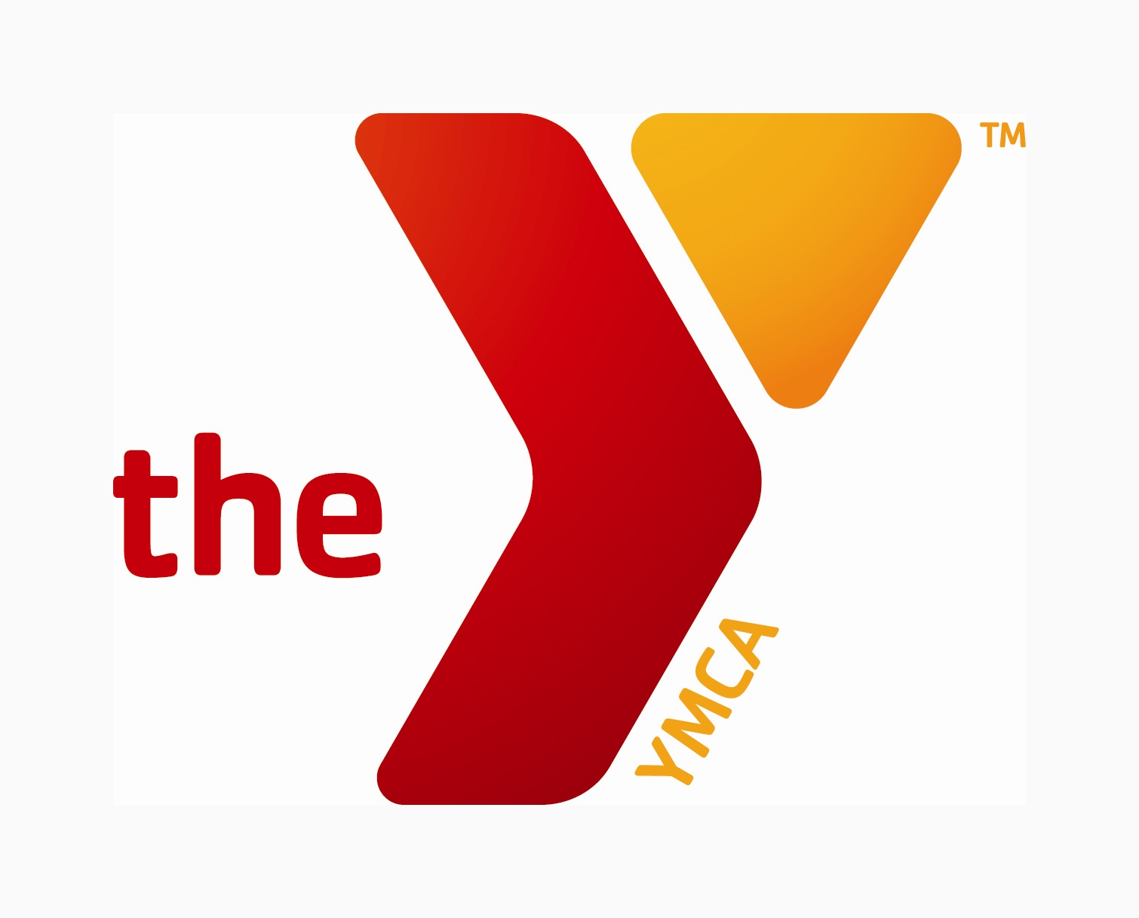
YMCA of Rock River Valley
Informed Consent for Exercise Participation

I desire to engage voluntarily in the YMCA Program in order to attempt to improve my physical fitness. I understand the activities are designed to place a gradually increasing workload on the cardiorespiratory system and to thereby attempt to improve its’ function. The reaction of the cardiorespiratory system to such activities cannot be predicted with complete accuracy. There is risk of certain changes that might occur during or following exercise. These changes might include abnormalities of blood pressure or heart rate.
I understand that the purpose of the exercise program is to develop and maintain cardiorespiratory fitness, body composition, flexibility, muscular strength and endurance. All exercise programs include a warm-up, exercise at target heart rate, and cool down. The programs may involve walking, jogging, swimming, or cycling; participation in exercise fitness, rhythmic aerobic exercise, or choreographed fitness classes; or calisthenics or strength training. All programs are designed to place a gradually increasing workload on the body in order to improve overall fitness.
I understand that I am responsible for monitoring my own condition throughout the exercise program and should any unusual symptoms occur, I will cease my participation and inform the wellness coach of the symptoms.
In signing this consent form, I affirm that I have read this information and that I understand the nature of the exercise program. I also affirm that my questions regarding the exercise program have been answered to my satisfaction.
In the event that a medical clearance must be obtained prior to my participation in the exercise program, I agree to consult my physician and obtain written permission from my physician prior to the commencement of any exercise program.
Also, in consideration for being allowed to participate in the YMCA FitPath Program, I have been informed of and understand and expressly acknowledge the inherent risks and assume those risks. I forever release, discharge, and covenant not to sue the YMCA for liability from any and all loss damage (personal injury, emotional or mental distress, property damage, economic loss, or wrongful death), whether or not caused by any negligence, either active or passive, by or on behalf of the YMCA. I will indemnify and hold the YMCA harmless from any and all claims made by others on my behalf.

Signature Date ______________________________________________________________________________________________________________

Please print:
Name ____________________________________
Birthdate ____________________________________Telephone_________________________________
Address _________________________________________________________________________________
Physician Name & Phone____________________________________________________________________
Limitations____________________________________________________________________________________

