Dear Parent/Guardian of _________________________ _______________________ ____________________
^{<<student name>>} ^{<<school name>>} ^{<<student I.D.>>}
If you wish to have transportation provided for your student, please check this box

Rockford Public Schools plans to provide transportation for students starting Sept. 2, 2020, the first day of school. This is a partnership between RPS 205 and our students and families. We need help and support from our families to keep our students and staff safe.

Our driver pool is limited, and we’re also limited to the number of students on each bus. It’s possible a bus will not be available at all times. If parents/guardians can find alternative transportation for their students, please do so. This will help families who have no other transportation options. If a bus route is changed or canceled, parents/guardians will be notified as soon as possible.

There are several new requirements and safety guidelines from the Illinois Department of Public Health and the Illinois State Board of Education because of the COVID-19 pandemic response. For a student to board the bus, parents/guardians must confirm each day that their student is free of any COVID-19 symptoms and has not been in contact with someone with COVID-19. To board the bus, students must:
- Wear a face covering to cover both the mouth and the nose.
- Carry an extra mask in case one is lost.
- Load the bus from back to front.
- Sit in an assigned seat.
- Sit two per seat. No more than 48 students will be assigned to each bus.

If your student shows signs of illness – such as flu-like symptoms, a persistent cough, fever, or other symptoms related to a cold or flu – your student must not come to school. If your student shows signs of illness at school, a parent/guardian must be available to take them home from school. Again, this is to keep our students and staff safe.

If your student is to be picked/dropped off at a sitter, which is a different address than you have on file, please check the box and fill out the form below. Please note, sitter request must adhere to the District’s sitter policies and are not guaranteed)
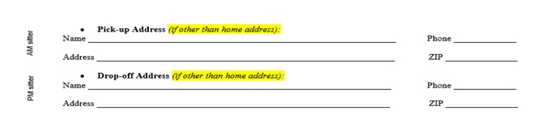

By printing your name and signing this document, the parent/guardian agrees to the above requirements and understands that RPS 205 will not provide transportation to students who do not comply with these requirements.

Thank you for your cooperation and understanding.
Sincerely,
RPS 205 Transportation Department

----------------------------------------------------------------------------------------------------------------------------------------------------------------
I, ___________________request RPS 205 bus transportation for ________________________ during the COVID-19
^{<<Parent/Guardian’s Name>>} ^{<<Student’s Full Name>>}
pandemic period. I agree to the mandatory requirements for boarding the bus and understand that failure to abide by the requirements will result in no transportation for my student until the requirements are met.
Parent/Guardian Signature _____________________________________Date______________________

